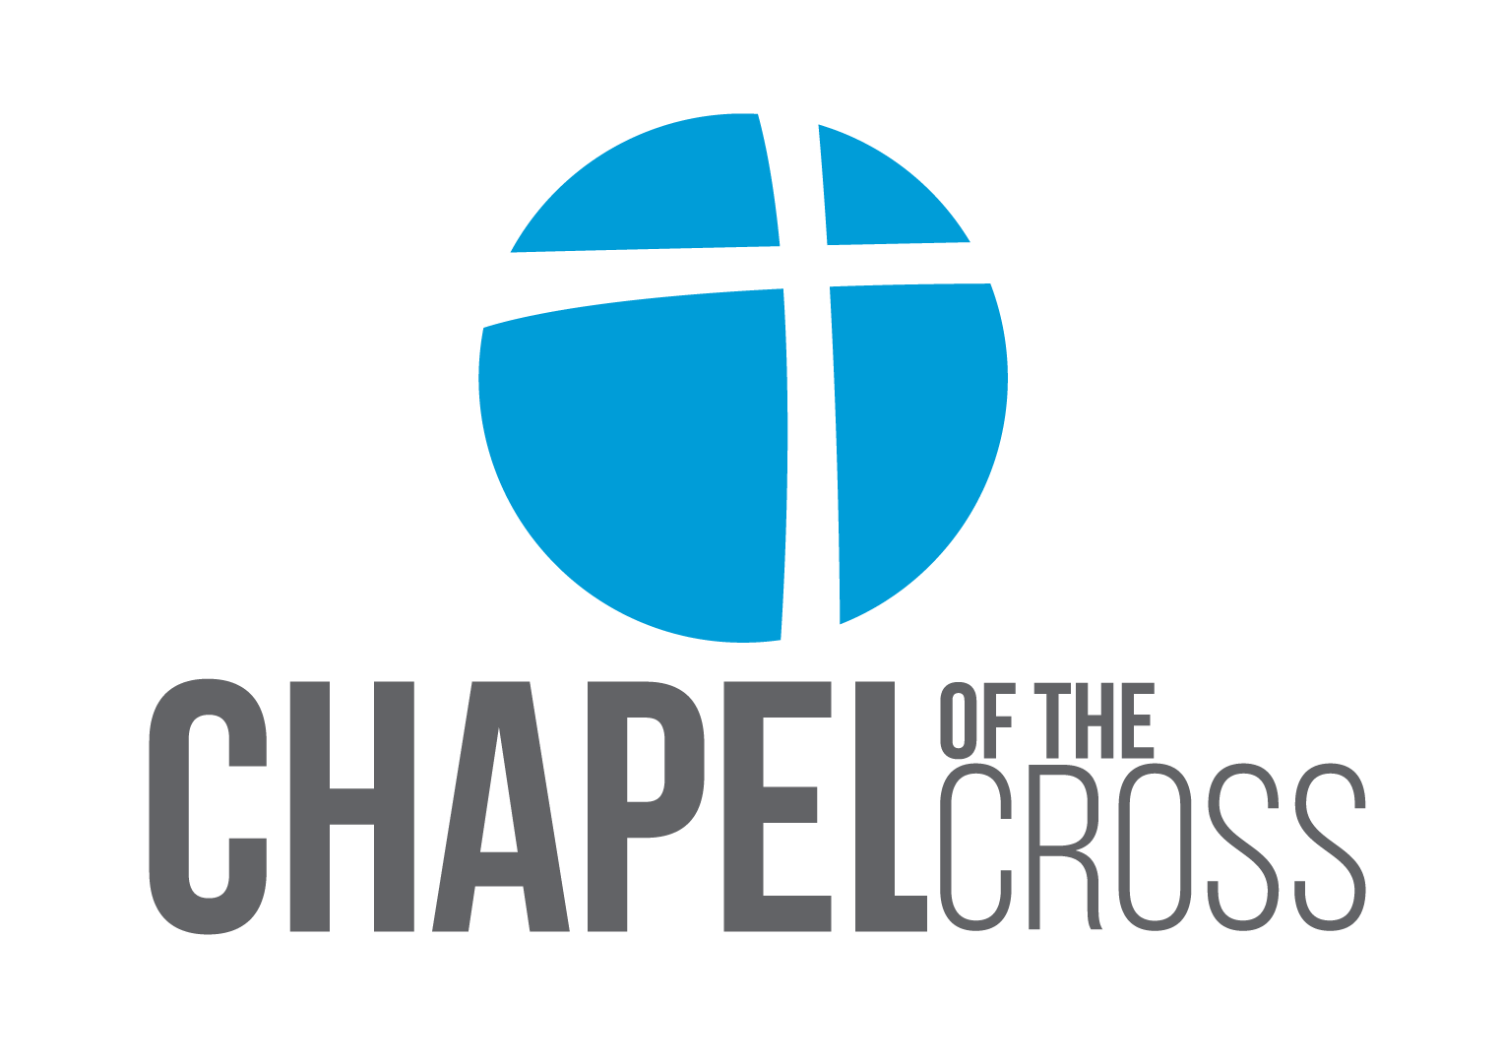
Description of Chapel of the Cross
Chapel of the Cross in Westborough, MA, is a growing community of people who seek to follow Jesus. Our goal is to engage with our greater community, gather as a church family, and grow in our relationship with each other and with Jesus. Chapel serves about 300 people from several towns in the MetroWest Massachusetts area. See more at www.chapelcares.com.

Student Director Job Description

Position Title: Director of Student Ministry (Full Time)
Primary Responsibilities: Oversee and execute all elements of the High School and Middle School Student Ministry experience, including weekend services, large group gatherings, small groups and discipleship events, student leadership training, retreats, and outreach on local campuses. Invest in the lives of students, establishing connections and cultivating relationships beyond Student Ministry programming. Recruit, develop, and shepherd volunteers in the student arena through the Student Ministry team.

Secondary Responsibilities: Our preference is to find someone who has the skill and desire to lead worship on Sunday mornings. Exact responsibilities in this area will be determined based on skill, experience, and present needs of the church. In addition to worship there may be other responsibilities based on giftedness, needs of leadership team, and your vocational aspirations and call. (Please Note: Although worship experience is preferred, those with no worship experience are welcome to apply)
Projected Start Date: As soon as possible
Reports to: Derek Duncan, Lead Pastor
Location: Chapel of the Cross
160 Flanders Road
Westborough, MA 01581
Church size: 300+ average attendance
Denomination: Converge International, formerly Baptist General Conference

Oversee the Student Ministry Experience:

- Create and communicate a clear vision for Student Ministry based on Chapel’s pillars of Engage, Gather, Grow.
- Develop and implement a curriculum plan that is fully integrated to flow out of Children’s Ministries, accomplish specific learning objectives, and prepare graduating students for life after high school.
- Oversee and plan a weekly gathering and worship experience that is fun, relevant, and engaging.
- Develop and implement a plan for Sunday mornings for Middle and High School students.
- Develop small groups for students that will drive the discipleship process in terms of the specific integrated objectives.
- Develop training for and disciple student leaders to use their gifts in the church and community.
- Develop and train students to lead worship through a youth worship band.
- Organize and lead retreats that will draw non-Christians to Christ as well as advance the discipleship process.
- Develop a strategy to reach new students in our surrounding schools.
- Develop a compelling mission strategy that allows students the opportunity to serve and minister to the world.
Invest in the Lives of Students:

- Regularly meet with students outside of Student Ministry events.
- Build relationships with parents to partner with them in their teen’s faith journey.
- Consistently communicate current events and future plans with parents and students.
Recruit, Develop, and Shepherd Volunteers:

- Recruit and develop volunteers for the Student Ministry Team.
- Give clear direction and training for volunteers and provide feedback as to performance.
- Utilize Student Ministry Team for program evaluation, strategic planning, and to maintain constant alignment with the mission of Chapel.
- Regularly shepherd and care for volunteers.
Other Duties:

- As a growing church, each staff member is engaged in defined responsibilities beyond their primary ministry function. Based on the gifts and talents of the person we hire; we will work together to discern and clarify in the final job description which other areas new team members will invest in beyond their primary function. As mentioned earlier, the ability to play an instrument and lead worship would be a plus.
- Be a positive voice for the staff and leadership of Chapel.
- Strive to make Chapel a training hub of pastors and leaders that will bless and equip other churches in New England.

Church Life:
- As a staff member here at Chapel it is expected that you will be actively involved in the church community outside your vocational ministry involvement.
- If you have a spouse, it will be important that your spouse is supportive of your role and feels called to be involved in church life here at Chapel.

Qualifications:
- Education: Minimum of a bachelor’s degree is required.
- Experience at directing or significantly contributing to student leadership at a local church.
- Demonstrate some ability in leading worship and developing a student ministry worship team.
- Skills in recruiting, team building, training volunteers, planning, and managing multiple details.
- Excellent interpersonal skills, both oral and written, and a positive attitude.
How to Apply:

- To apply for this position, please submit a resume with cover letter, as well as a link to a video of you teaching or preaching to Derek at derek@chapelcares.com The video can be as simple as an iPhone video.

